Software Engineering Lab 2
Adithya, PES1UG24CS021, 5A

User Stories:
Compatible Charger Matching and Reservation
As an EV driver, I want the system to match my vehicle connector type with available charging stations and reserve a 30-minute charging window, so that I can charge my vehicle using a compatible charger without conflicts.

Real-Time Charging Socket Availability
As an EV driver, I want to see the real-time availability status of each charging socket, so that I can avoid arriving at a station with a busy or unavailable charger.

Dynamic Charging Cost Estimation
As an EV driver, I want to see the estimated total cost of a charging session based on the station's dynamic power rate, so that I can make an informed decision before confirming my reservation.

Manage Socket Out-of-Service Status
As a Station Operator, I want to mark a specific charging socket as out of service, so that unavailable equipment is removed from driver search results and cannot be reserved.

Reservation Confirmation Notification
As an EV driver, I want to receive a confirmation notification after a successful reservation, so that I have the station location, socket ID, and reserved time window as a reference.

Burndown Chart:
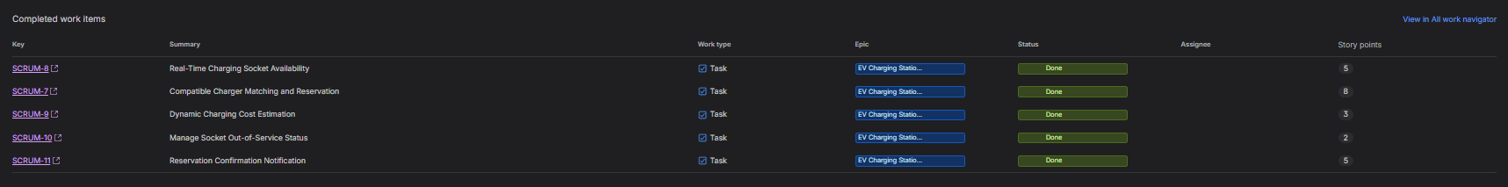

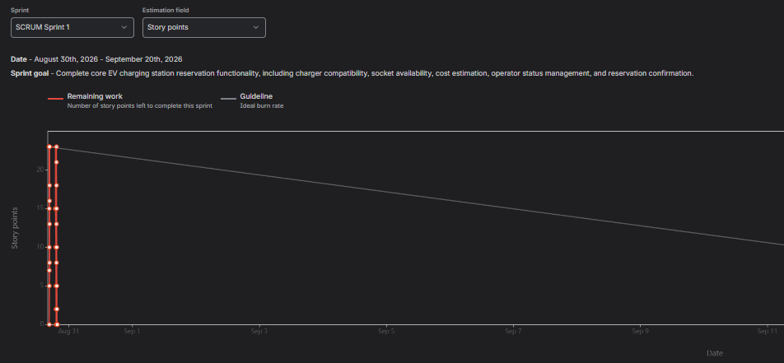

EPIC Summary:
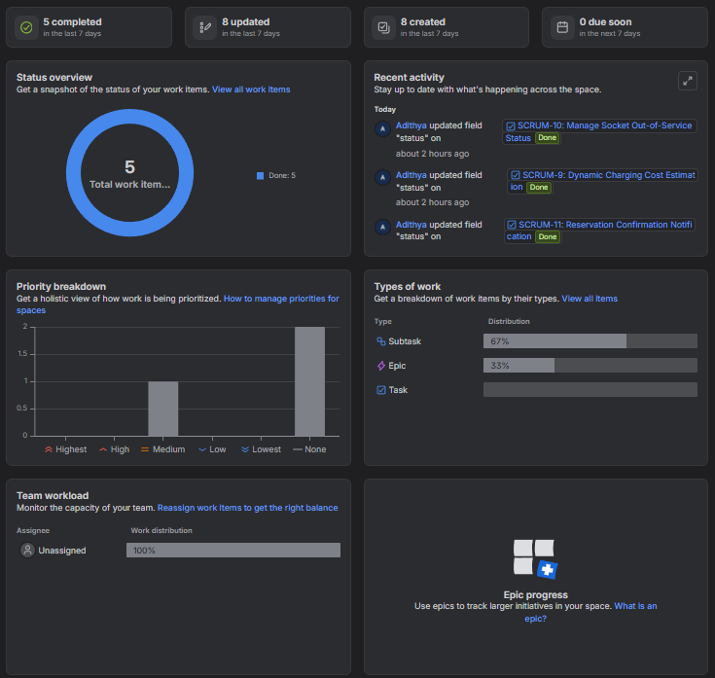

Reflection Questions
1. Did your estimations reflect the actual effort?
Yes. The story-point estimates provided a reasonable representation of the relative effort required for the tasks. The larger tasks, such as Compatible Charger Matching and Reservation, were assigned higher points, while simpler tasks, such as Manage Socket Out-of-Service Status, received fewer points. Overall, the 23 story points were completed within the sprint.

2. Was your backlog well-prioritised?
Yes. The backlog was prioritised according to the importance and complexity of the requirements. Higher-priority tasks such as charger compatibility, socket availability, and reservation confirmation were addressed before medium-priority tasks such as cost estimation and socket status management.

3. How did your simulated sprint align with your plan?
The sprint aligned well with the planned scope. Five work items totalling 23 story points were included in the sprint, and all five were successfully moved through the workflow and completed. The sprint therefore achieved its planned goal of implementing the core EV charging station reservation functionality.

4. What insights did the burndown chart give about your team’s capacity?
The burndown chart showed that the team had a planned workload of 23 story points and successfully completed the entire sprint scope. This provides an initial indication that the team can handle approximately 23 story points for a one-week sprint under similar conditions. Future sprints can use this as a baseline for estimating the team's capacity and deciding how much work to commit to.

